<https://www.youtube.com/watch?v=D0efHEJsfHo&list=PLblh5JKOoLUICTaGLRoHQDuF_7q2GfuJF&index=41>



Today we're going to talk about how to prune regression trees.

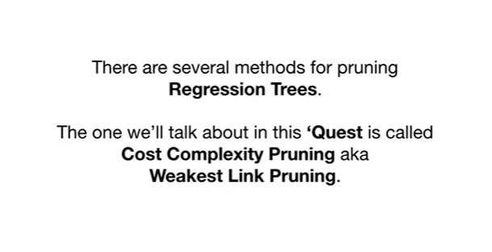

There are several methods for pruning regression trees.

The one we'll talk about in this quest is called cost complexity pruning aka weakest link pruning.



We'll start by giving a general overview of how cost complexity pruning works and then will describe how it's used to build regression trees.

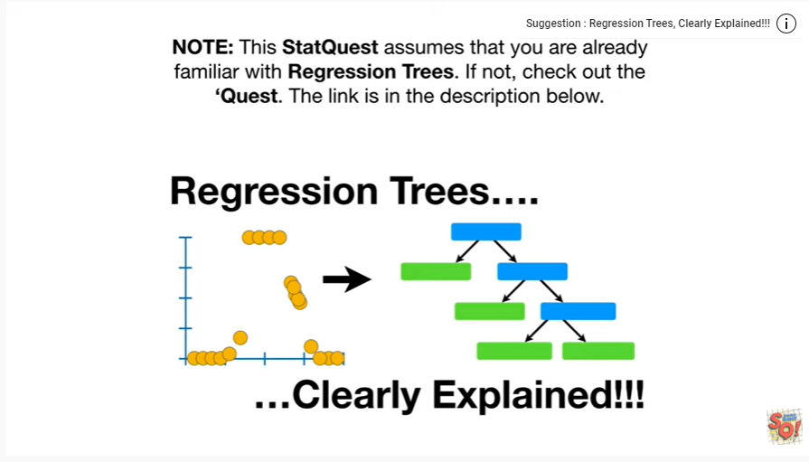

Note :this stat quest assumes that you are already familiar with regression trees.

If not check out the quest, the link is in the description below.



Also note this stat quest assumes that you are already familiar with cross-validation.

If not check out the quest.

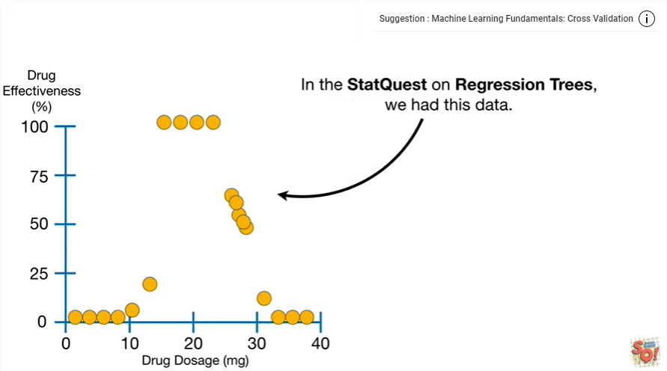

In the stack quest on regression trees we had this data.

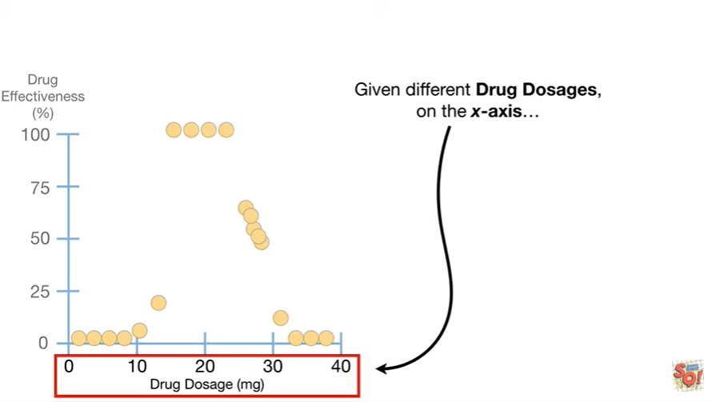

Given different drug dosages on the x-axis

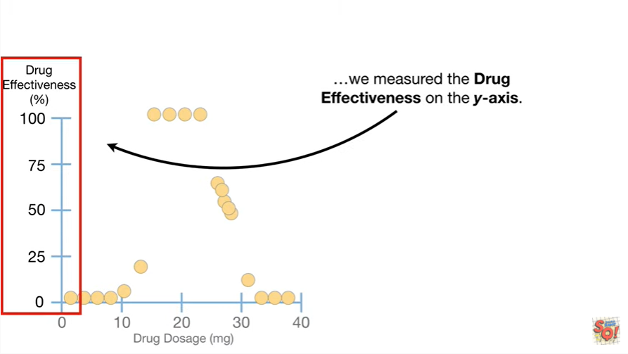

we measured the drug effectiveness on the y-axis.

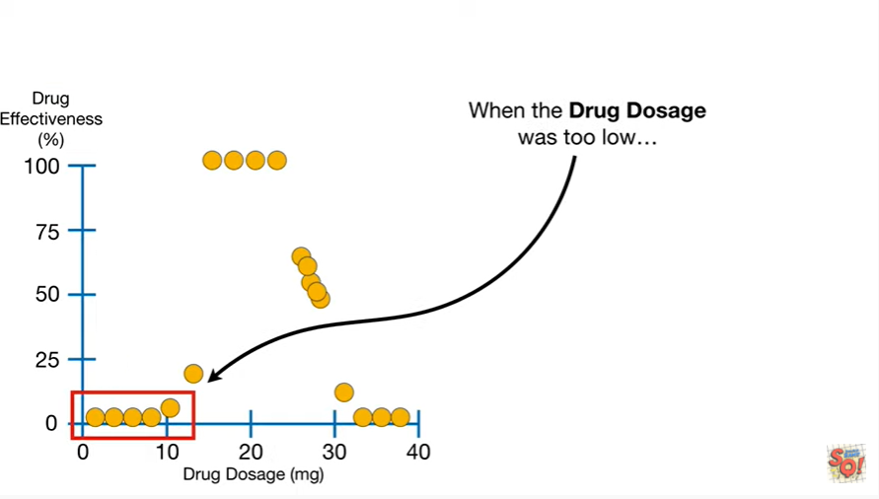

When the drug dosage was too low

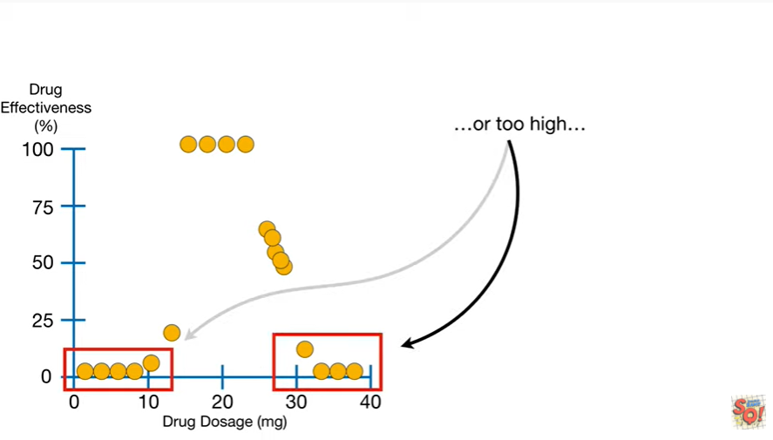

or too high

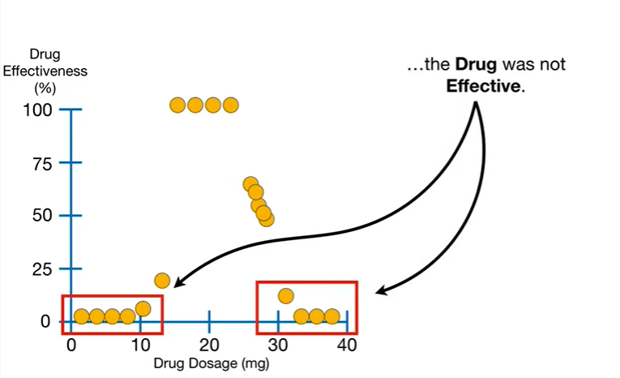

the drug was not effective.

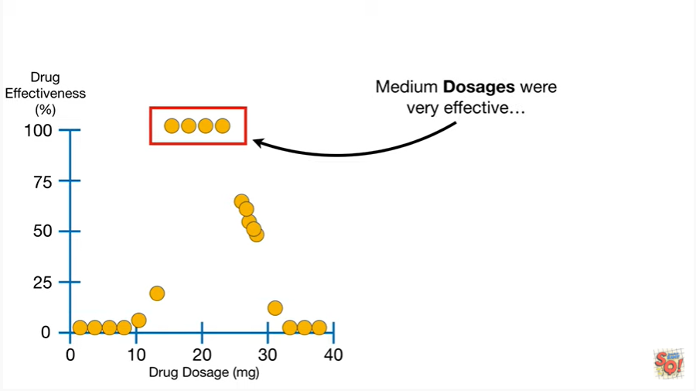

Medium dosages were very effective

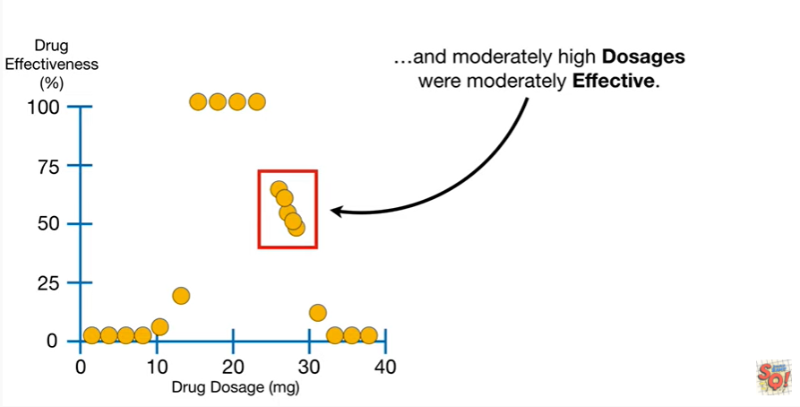

and moderately high dosages were moderately effective.

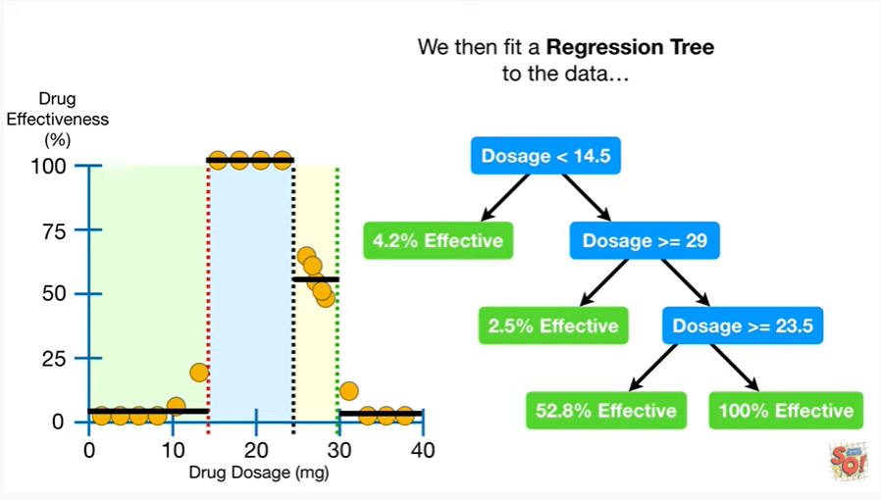

We then fit a regression tree to the data

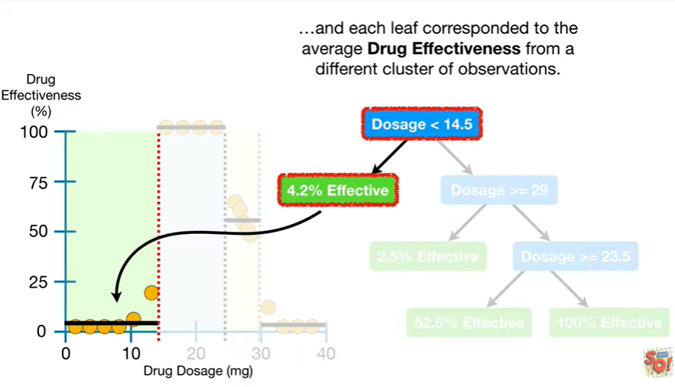

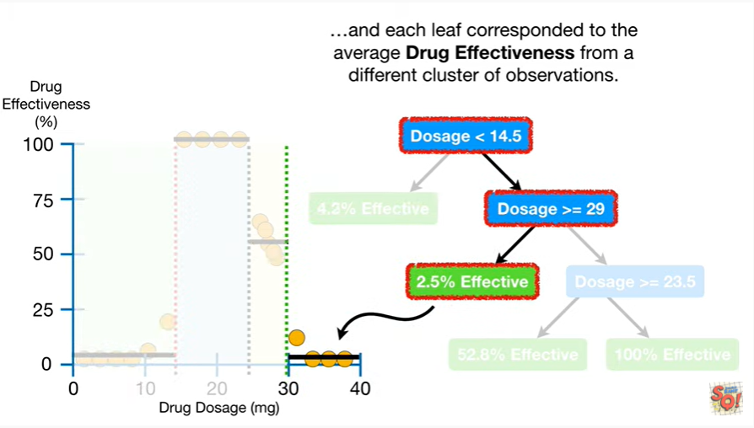

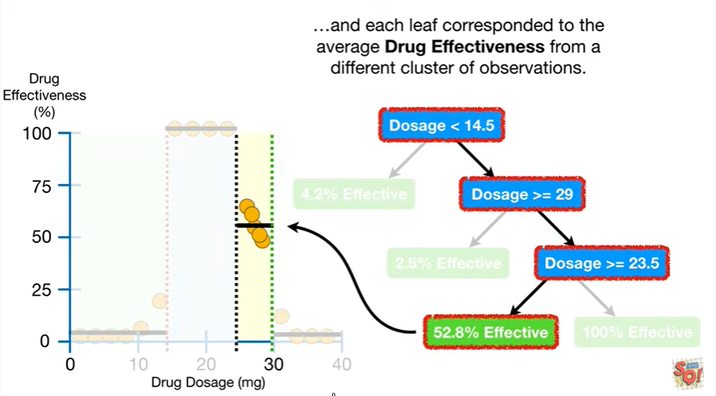

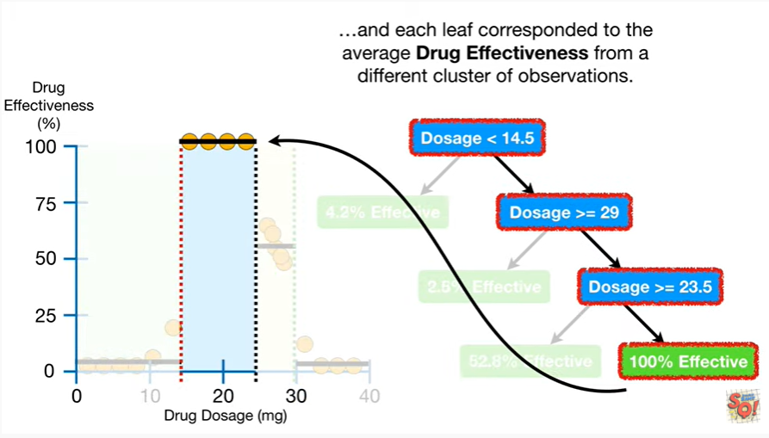

and each leaf correspond to the average drug effectiveness from a different cluster of observations.

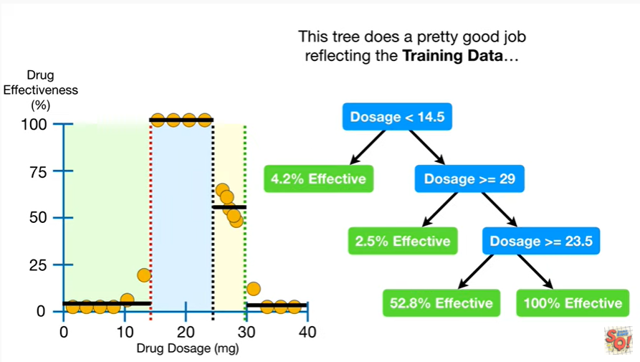

This tree does a pretty good job reflecting the training data

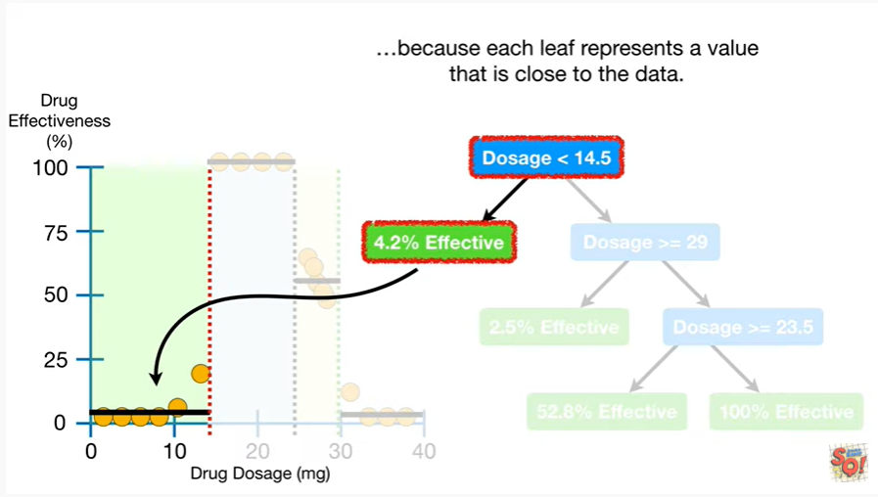

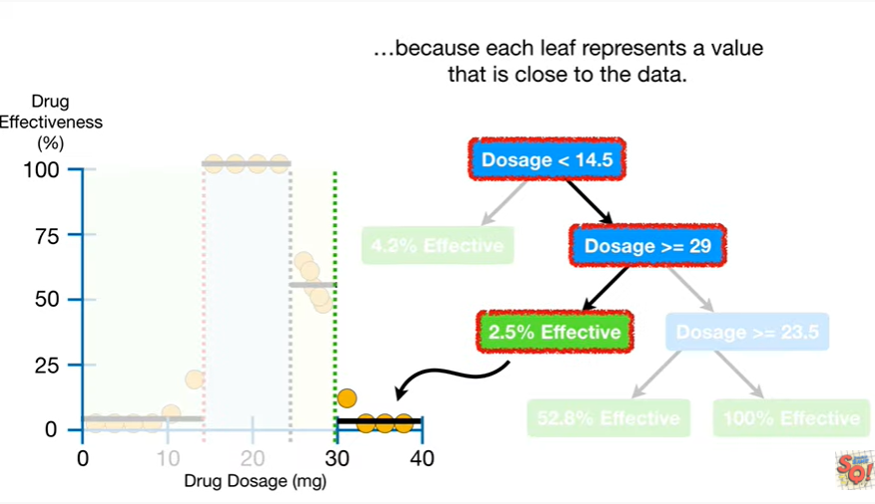

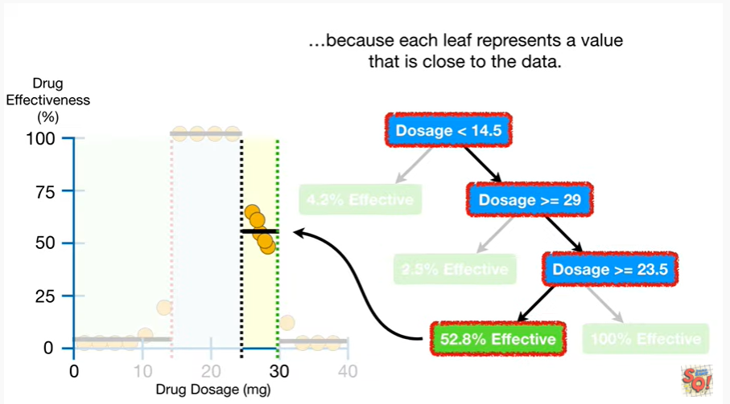

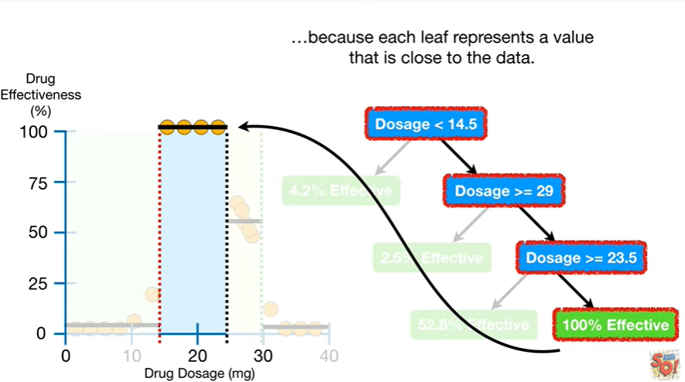

because each leaf represents a value that is close to the data.

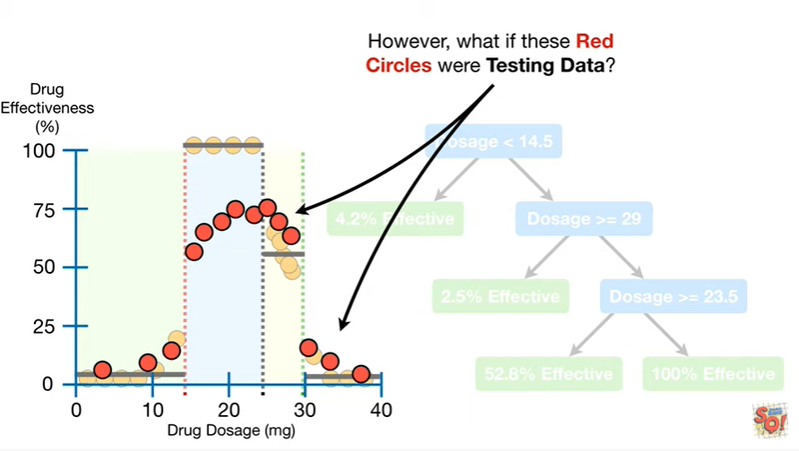

However, what if these red circles were testing data.

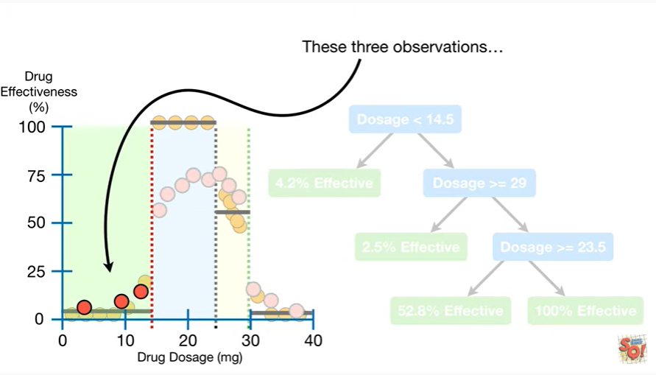

These three observations

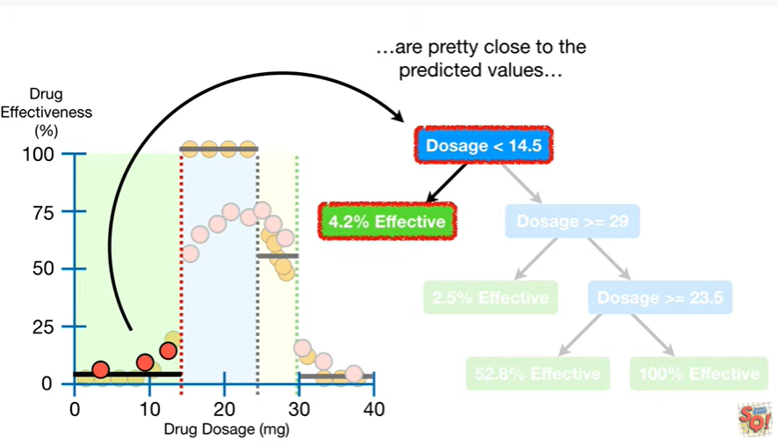

are pretty close to the predicted values

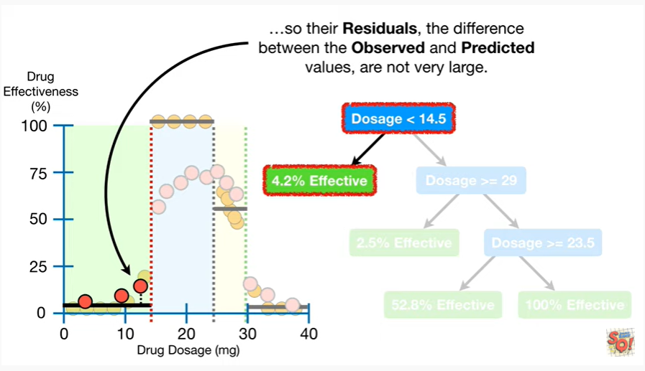

so their residuals the difference between the observed and predicted values, are not very large.

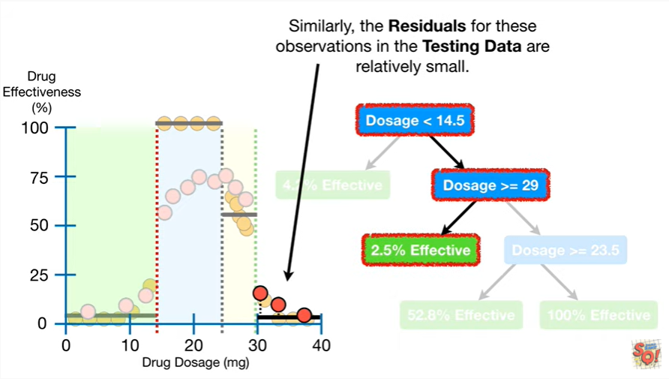

Similarly the residuals for these observations in the testing data are relatively small.

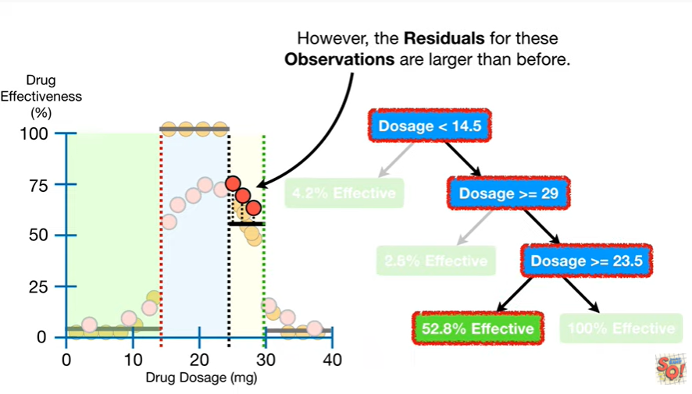

However, the residuals for these observations are larger than before.

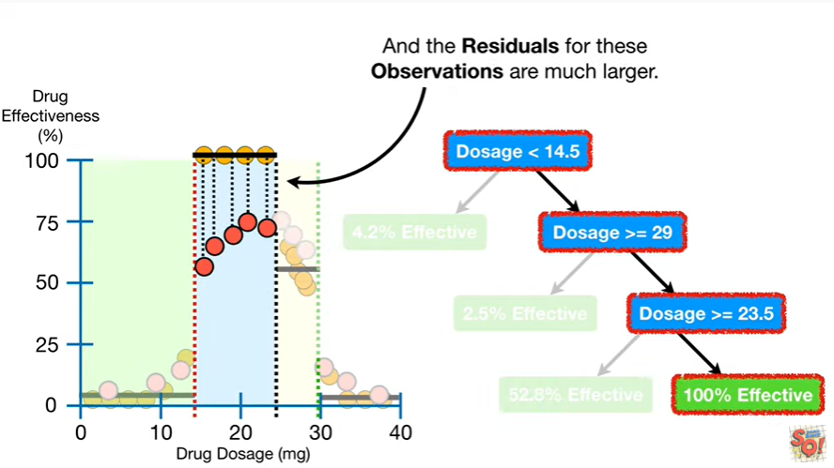

And the residuals for these observations are much larger.

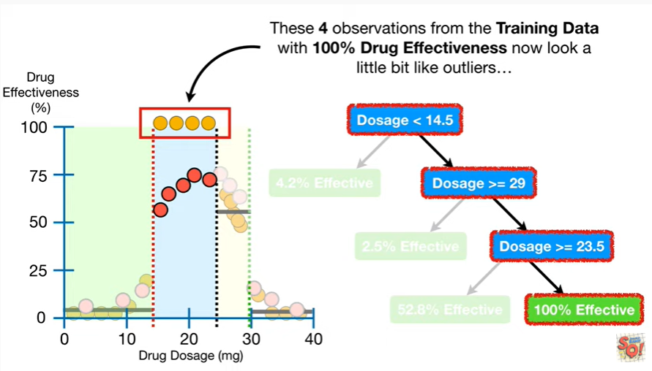

These four observations from the training data with 100% drug effectiveness now look a little bit like outliers

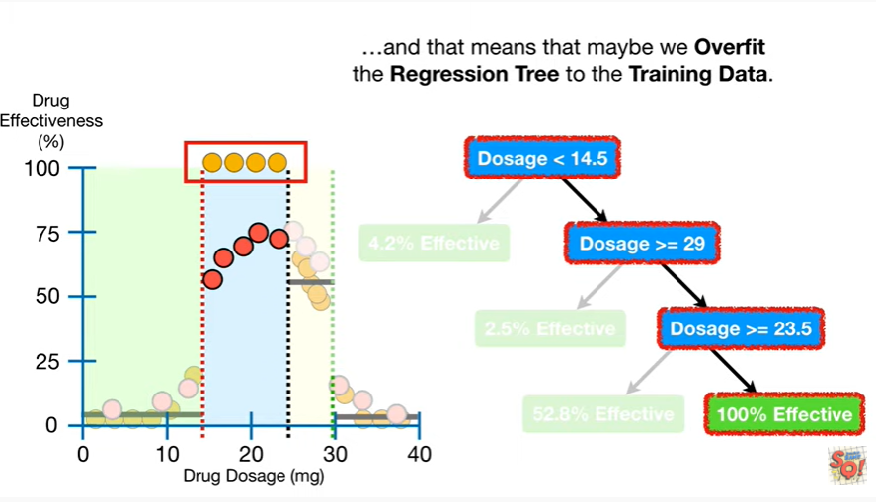

and that means that we over fit the regression tree to the training data.

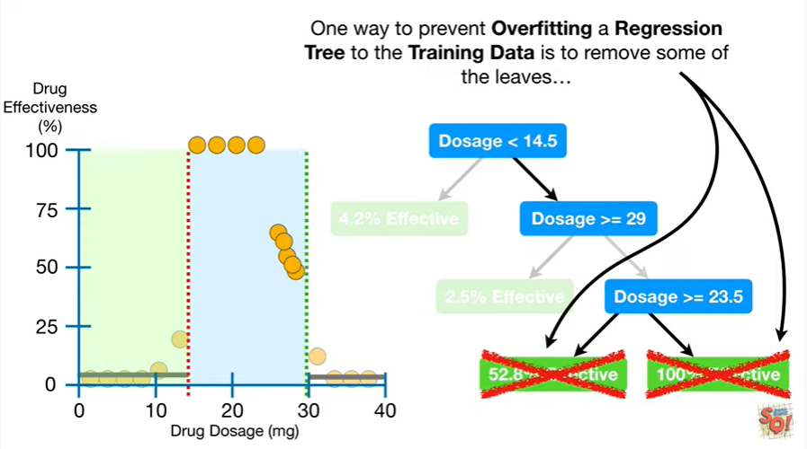

One way to prevent over-fitting a regression tree to the training data is to remove some of the leaves

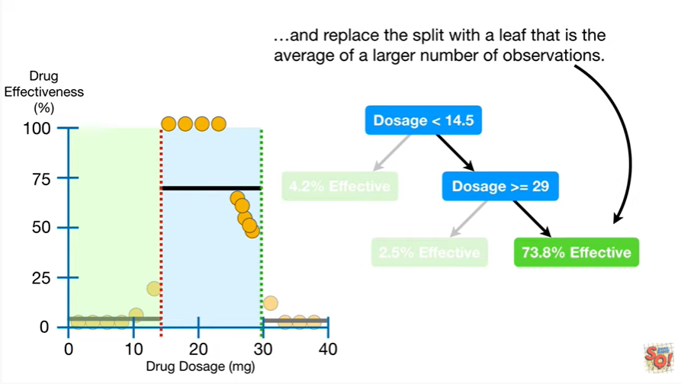

and replace the split with a leaf that is the average of a larger number of observations.

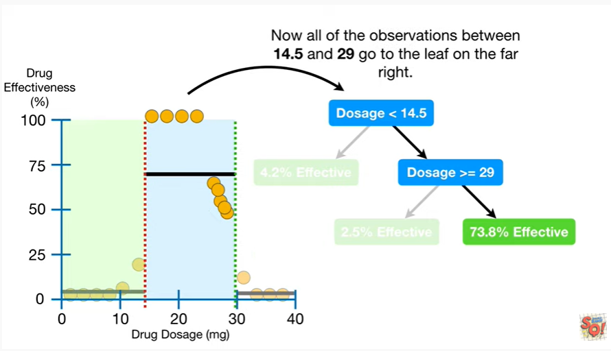

Now all of the observations between 14.5 and 29 go to the leaf on the far right.

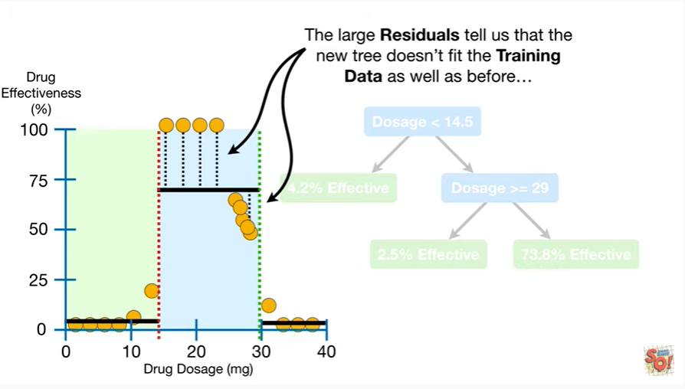

The large residuals tell us that the new tree doesn't fit the training data as well as before

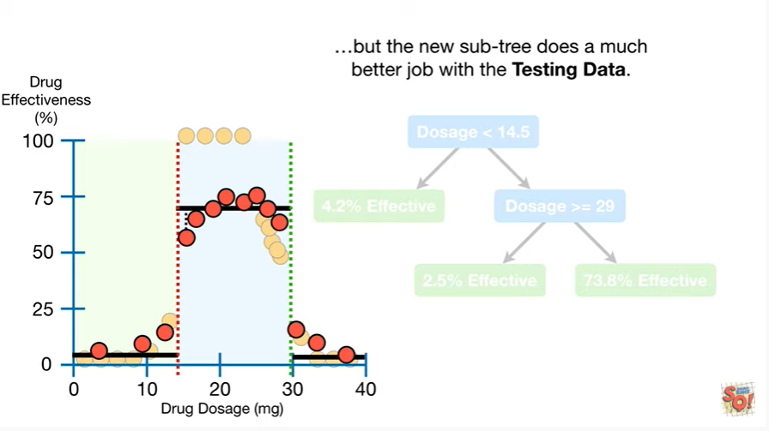

but the new subtree does a much better job with the testing data.

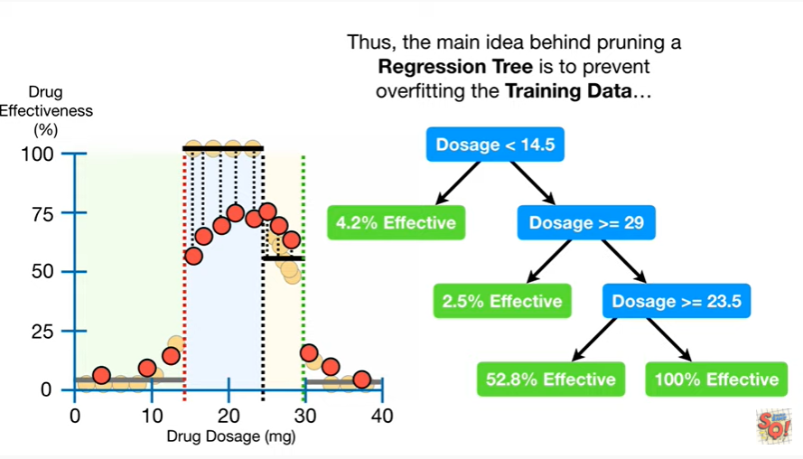

Thus the main idea behind pruning a regression tree is to prevent overfitting the training data

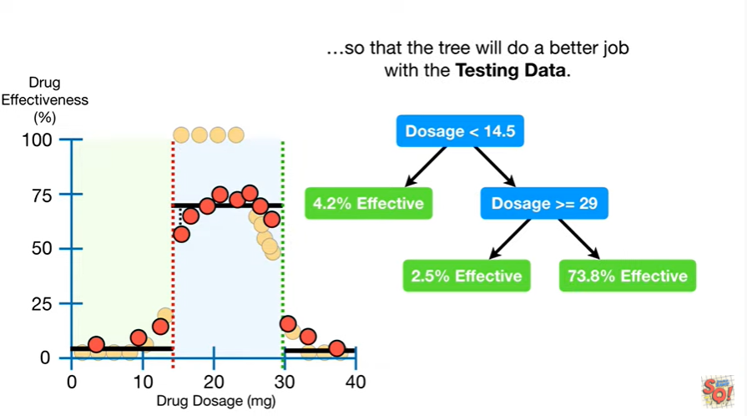

so that the tree will do a better job with the testing data.

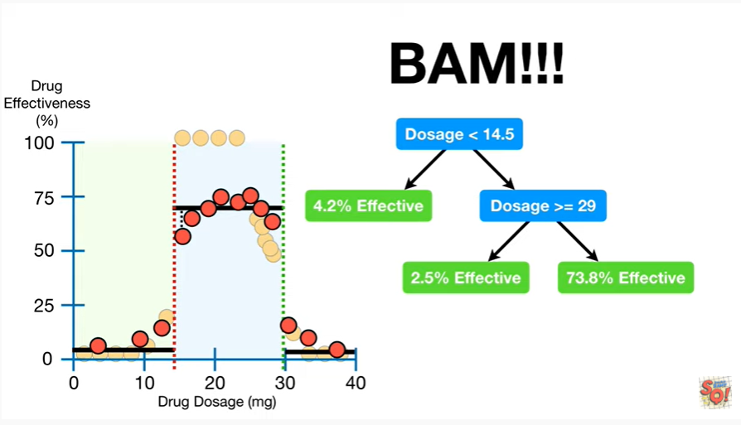

BAM !!!

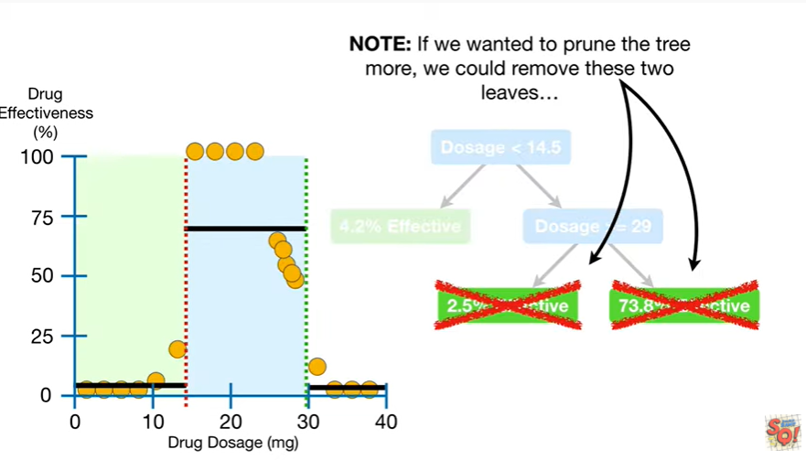

Note : if we wanted to prune the tree more we could remove these two leaves

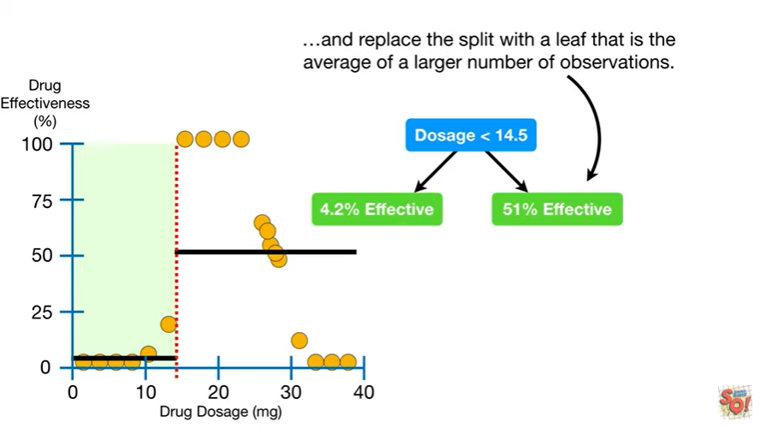

and replace the split with a leaf that is the average of a larger number of observations

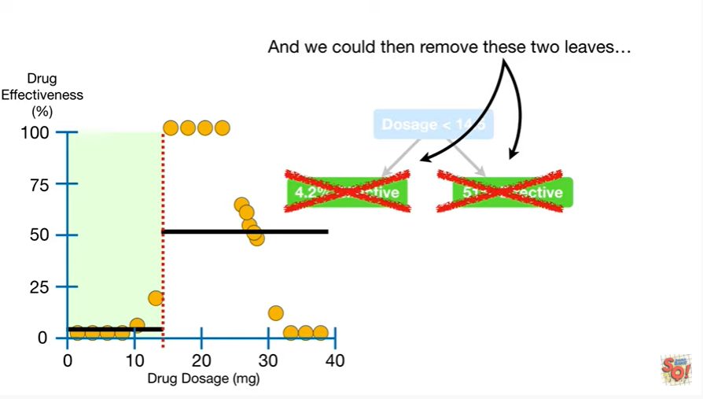

and we could then remove these two leaves

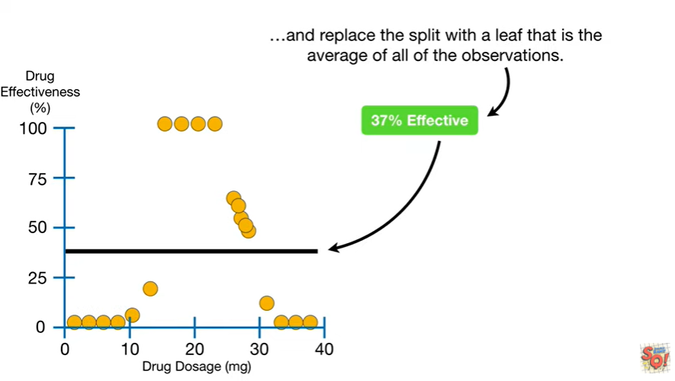

and replace the split with a leaf that is the average of all of the observations.

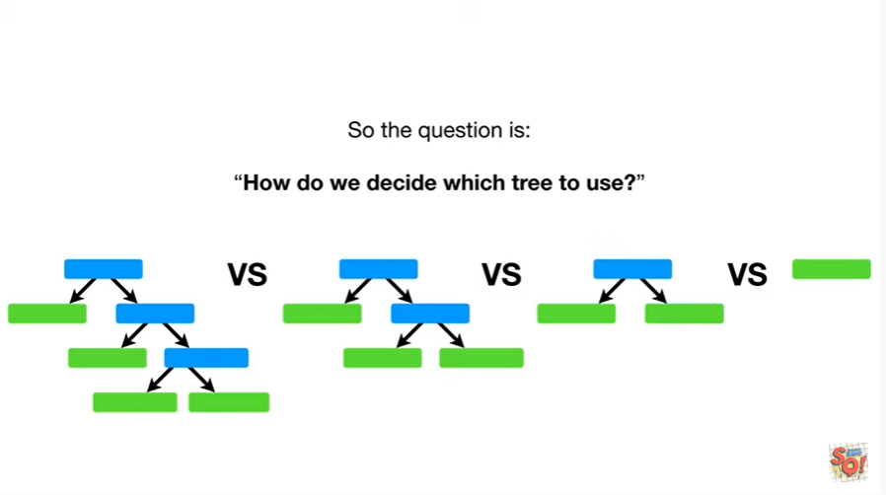

So the question is : how do we decide which tree to use ?

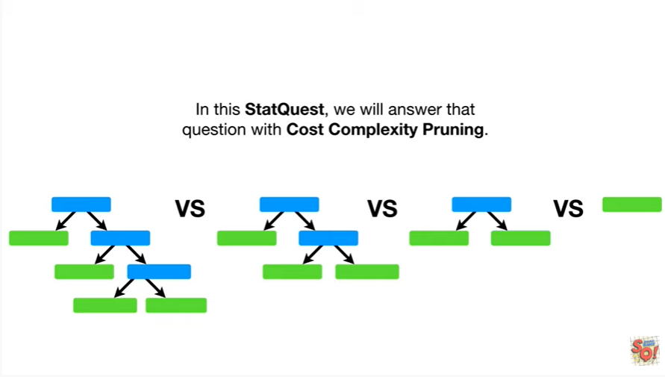

In this stat quest, we will answer that question with cost complexity pruning.

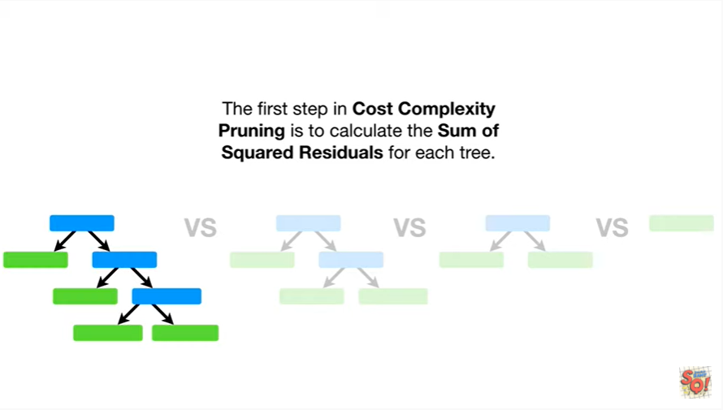

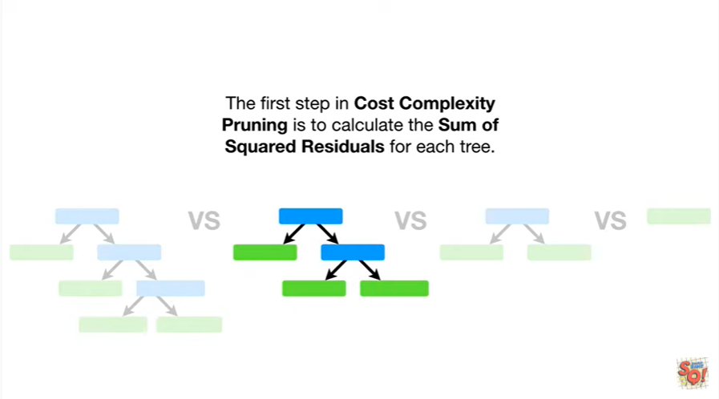

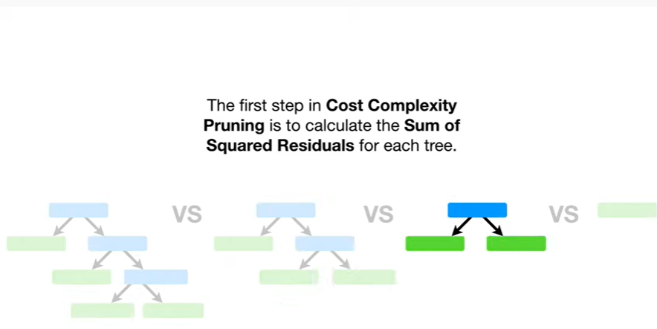

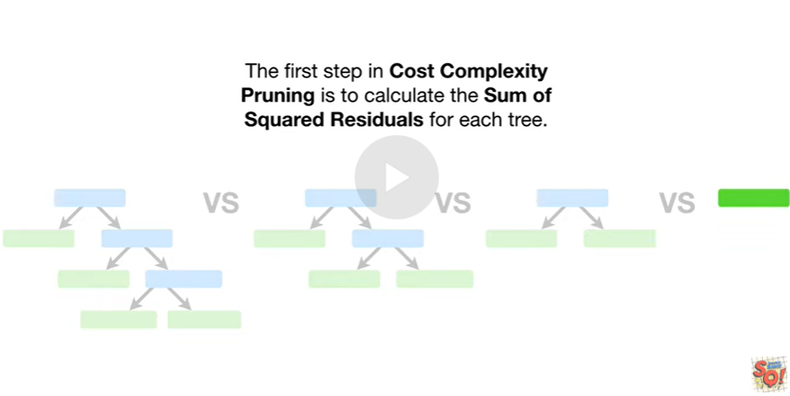

The first step in cost complexity pruning is to calculate the sum of the squared residuals for each tree.

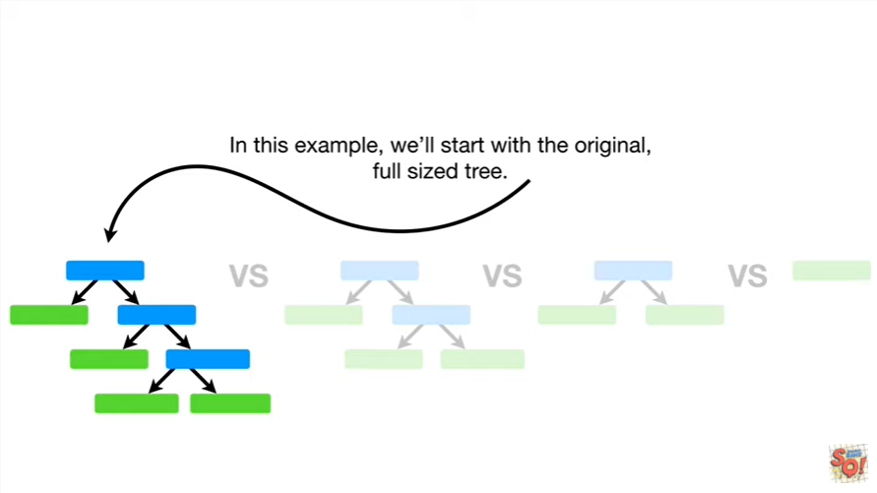

In this example, we'll start with the original full-sized tree.

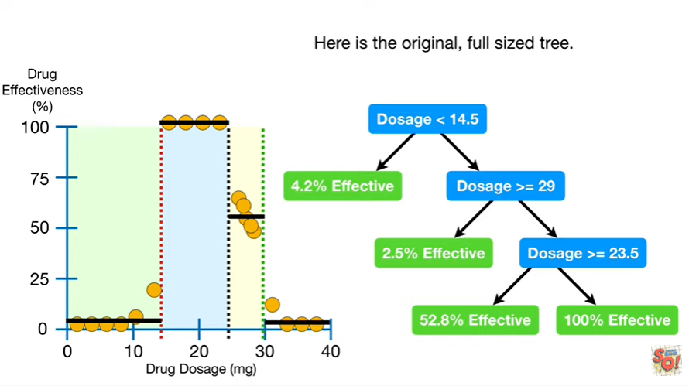

Here is the original, full-sized tree.

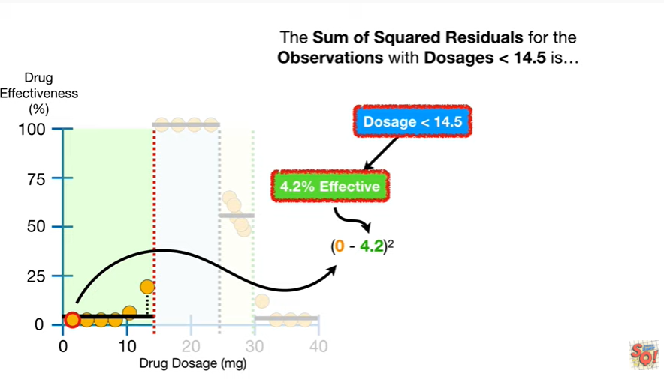

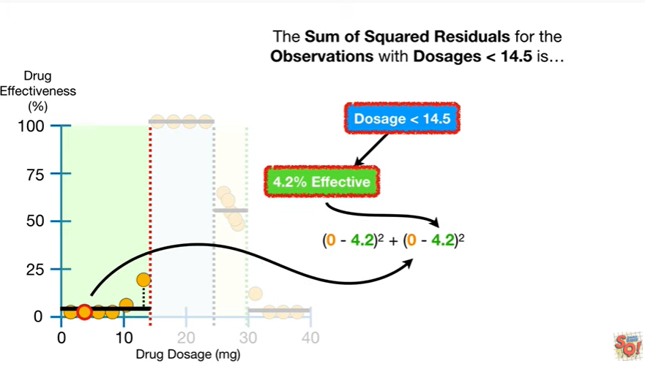

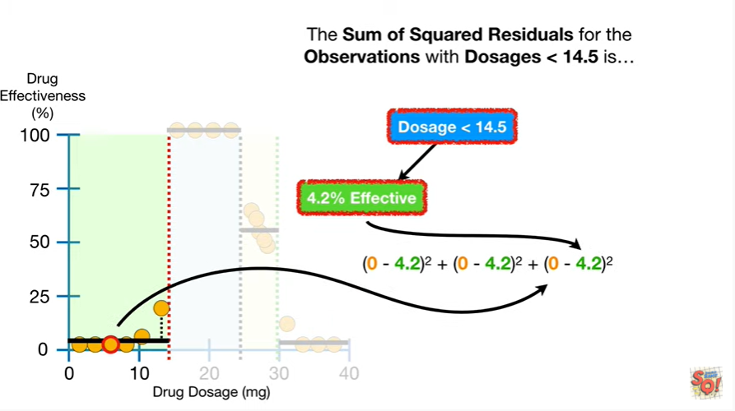

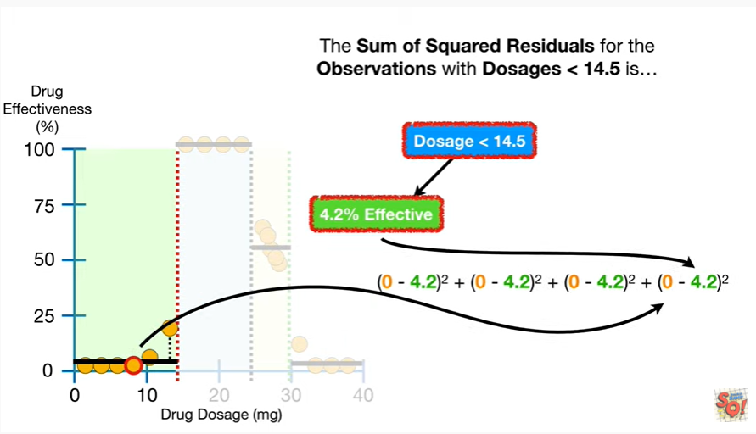

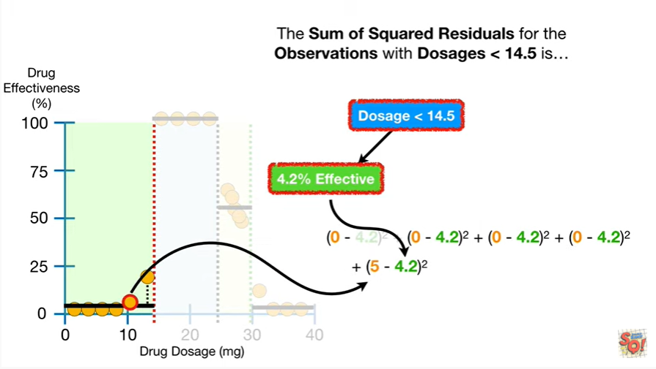

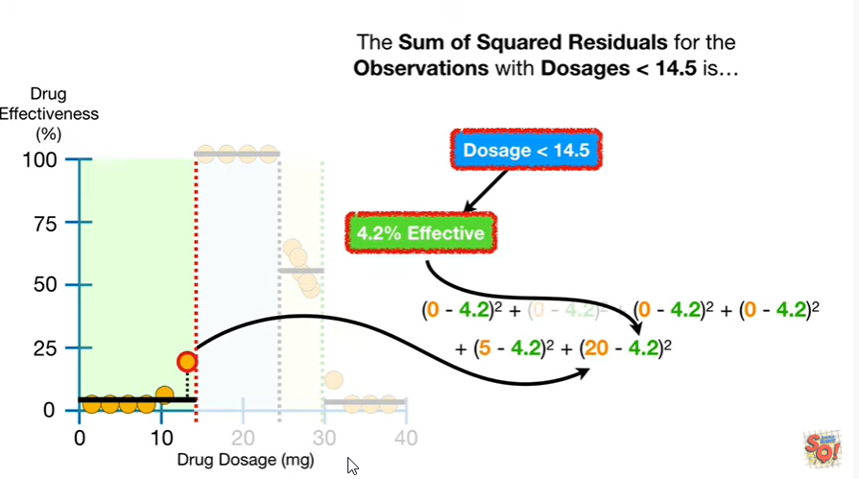

Some of the squared residuals for the observations with dosages less than 14.5 is

d tu tutitu tutitu tu tu

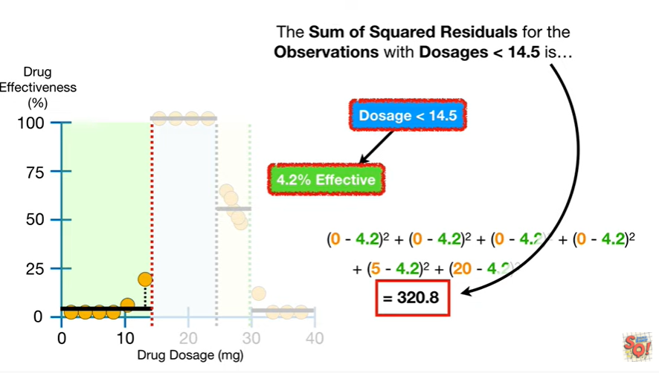

320 point 8.

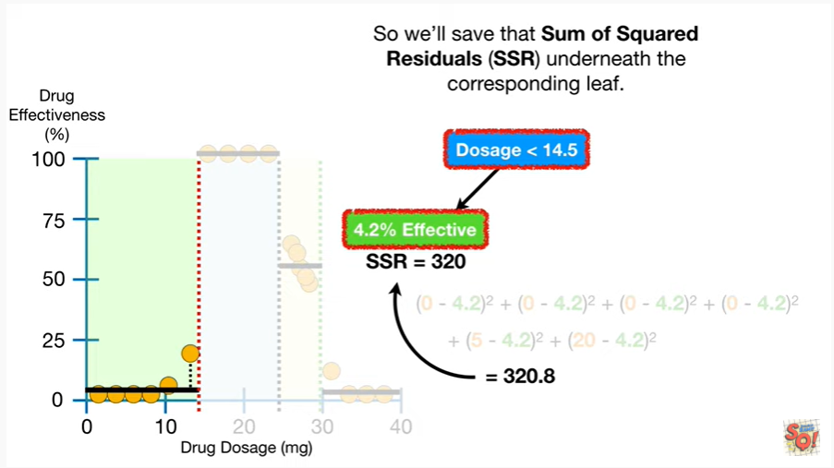

So we'll save that sum of squared residuals underneath the corresponding leaf.

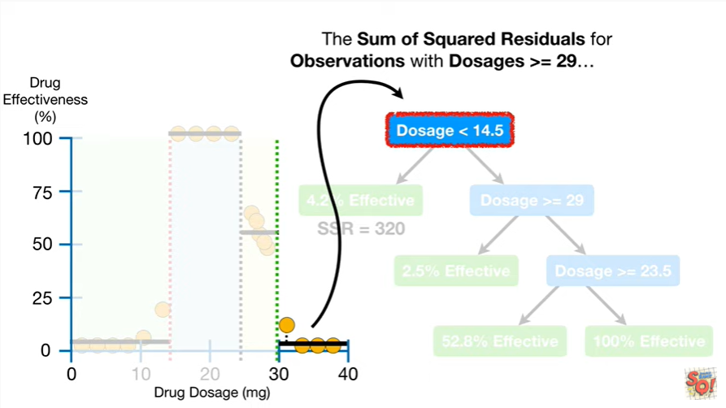

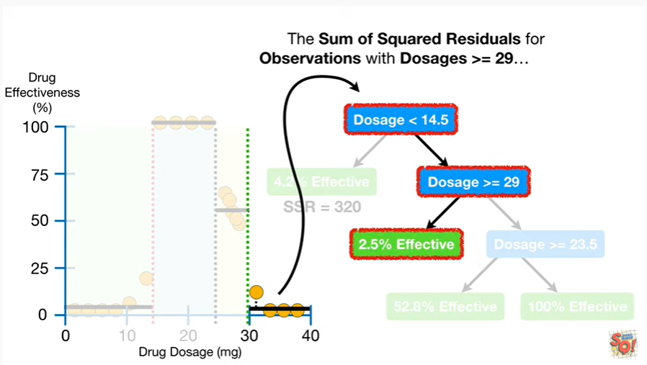

Some of squared residuals for observations with dosages greater than or equal to 29

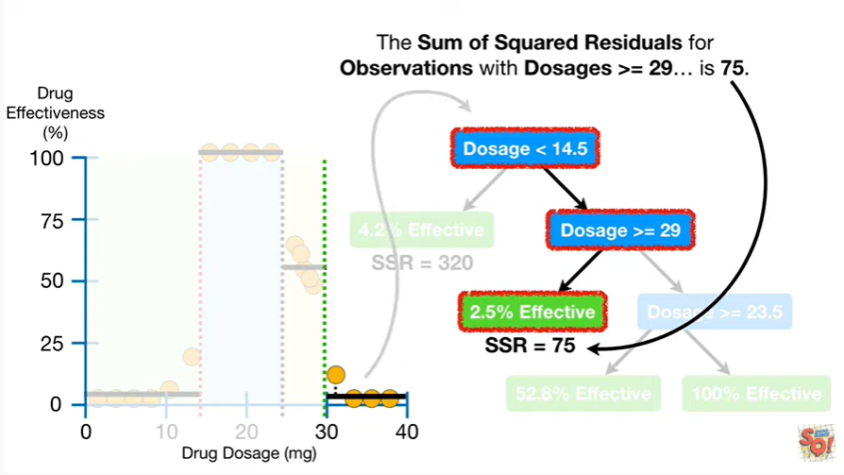

is 75.

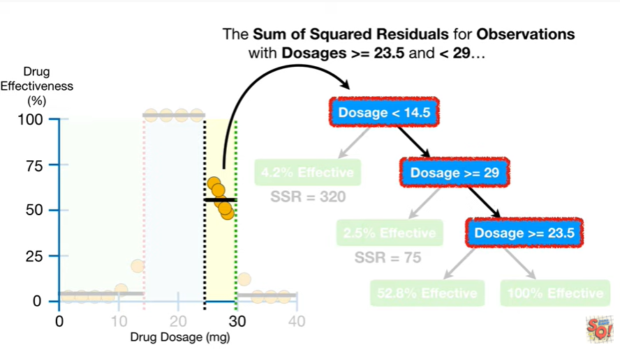

The sum of squared residuals for observations with dosages greater than or equal to 23 in less than 29

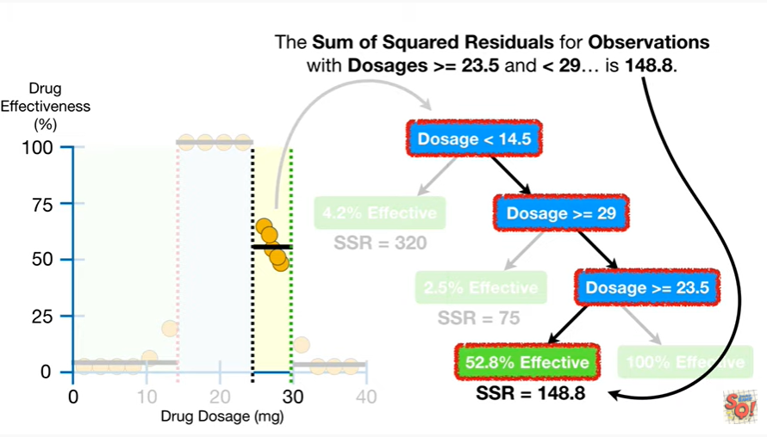

is 148.8.

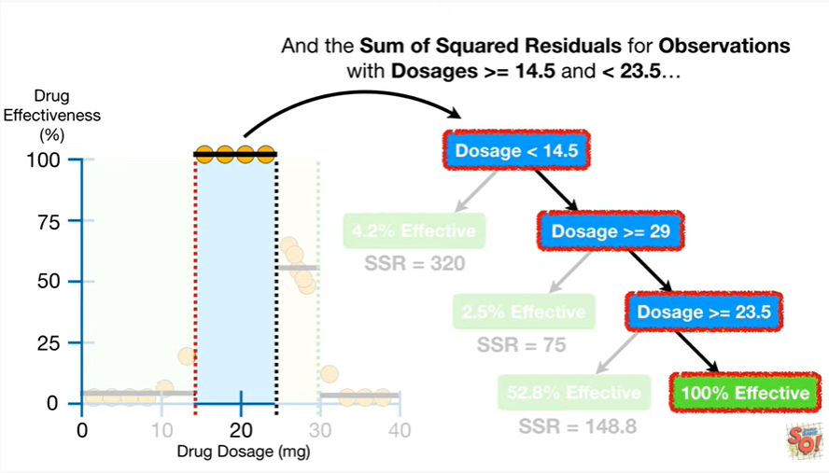

And the sum of squared residuals for observations with dosages greater than or equal to 14.5 and less than twenty three point five

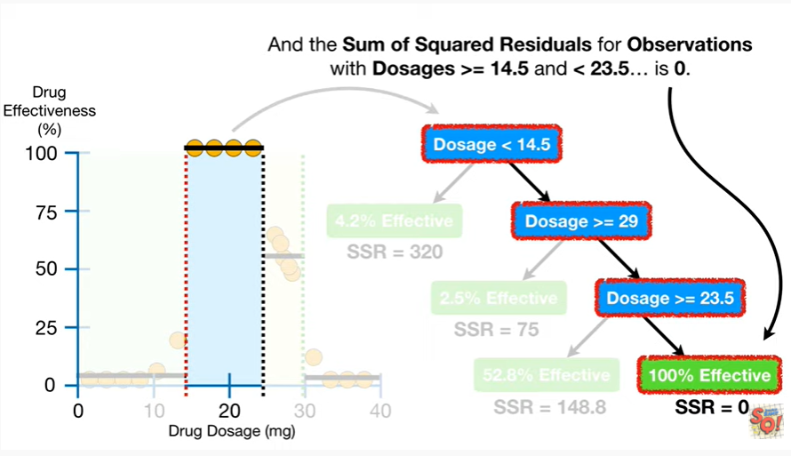

is zero.

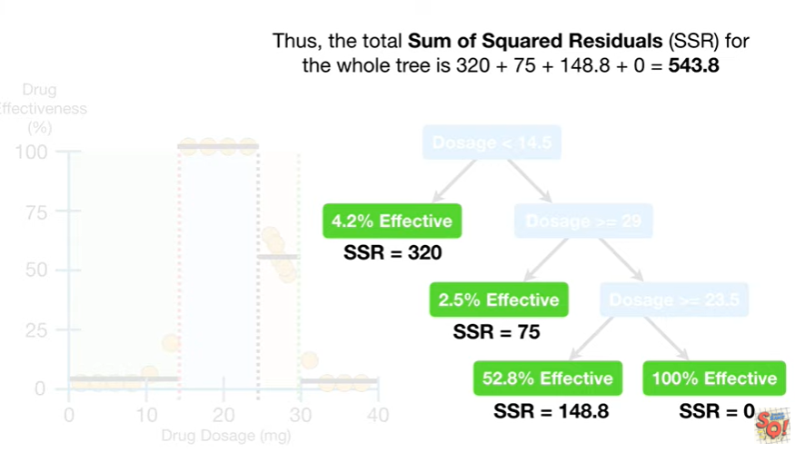

Thus the total sum of squared residuals for the whole tree is 320 plus seventy five plus one hundred forty eight point eight plus zero equals five hundred forty three point eight.

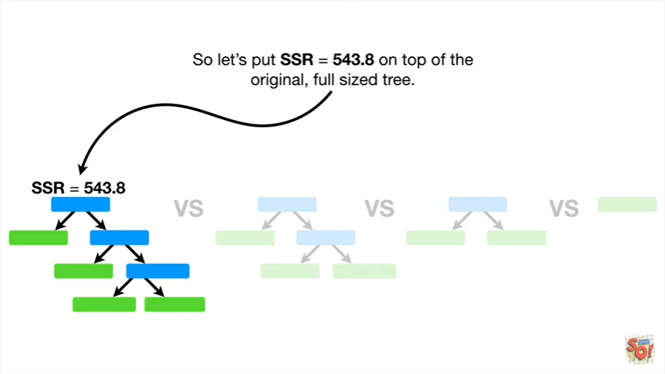

So let's put SSR equals five hundred forty three point eight on top of the original full-sized tree.

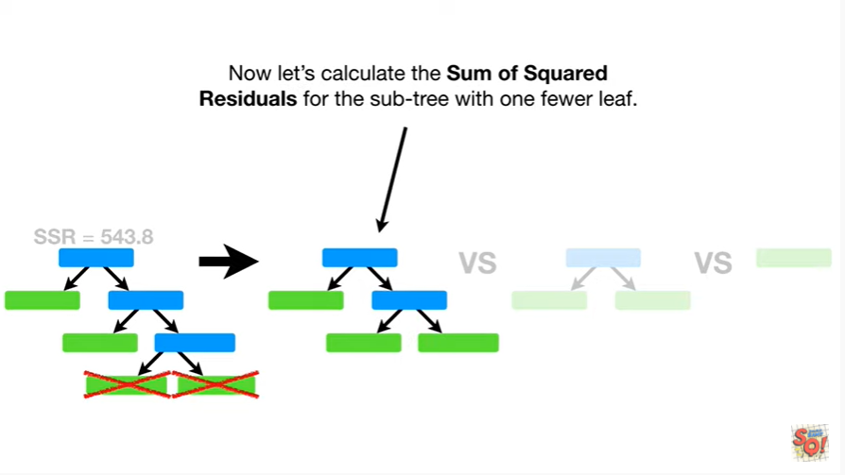

Now let's calculate the sum of squared residuals for the subtree with one fewer leaf.

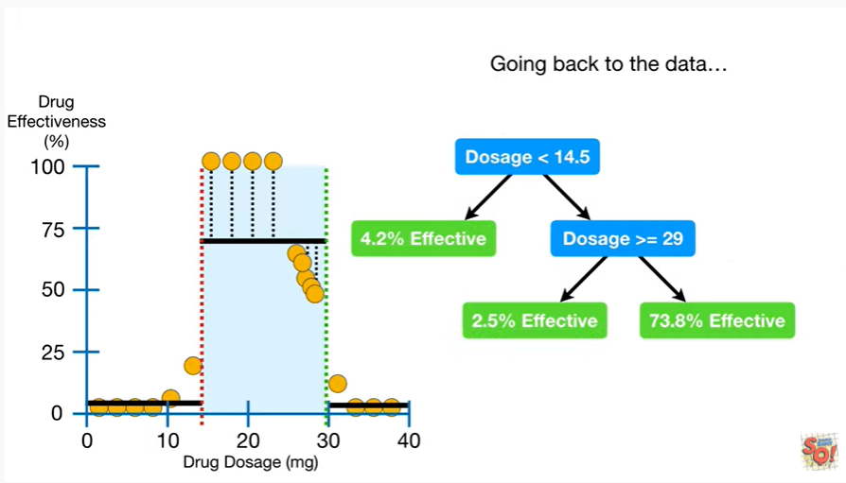

Going back to the data

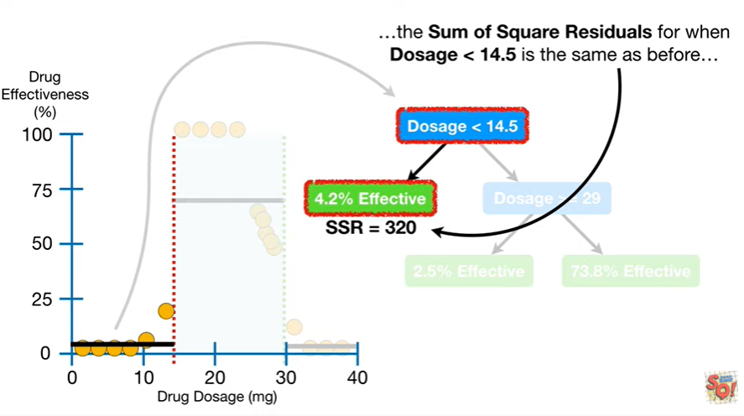

the sum of squared residuals for when dosage is less than 14.5 is the same as before

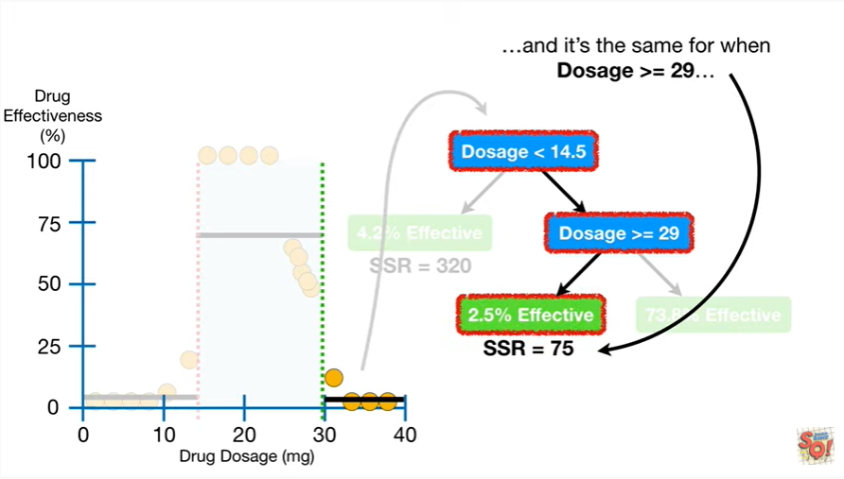

and it's the same for when dosage is greater than or equal to 29

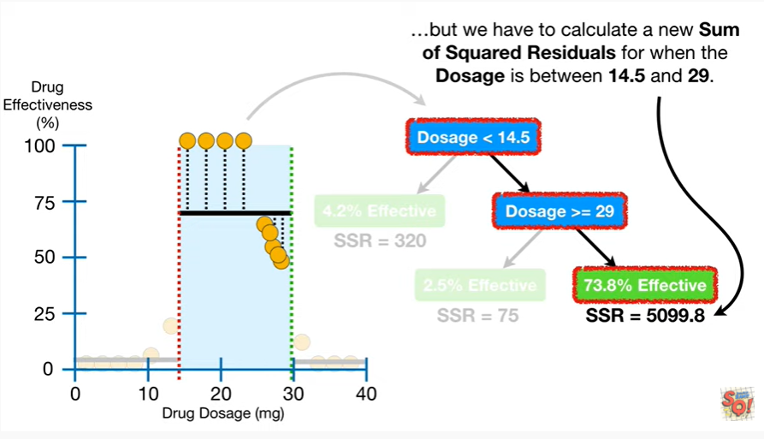

but we have to calculate a new sum of squared residuals for when the dosage is between 14.5 and 29.

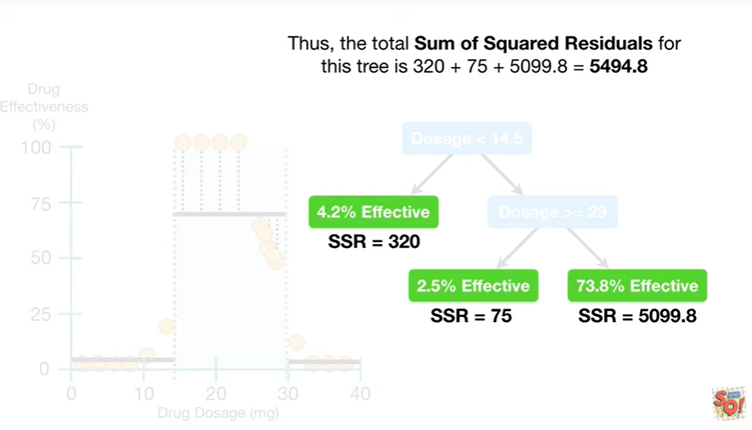

Thus the total sum of squared residuals for this tree is three hundred twenty plus seventy five plus five thousand ninety nine point eight which equals five thousand four hundred ninety four point eight.

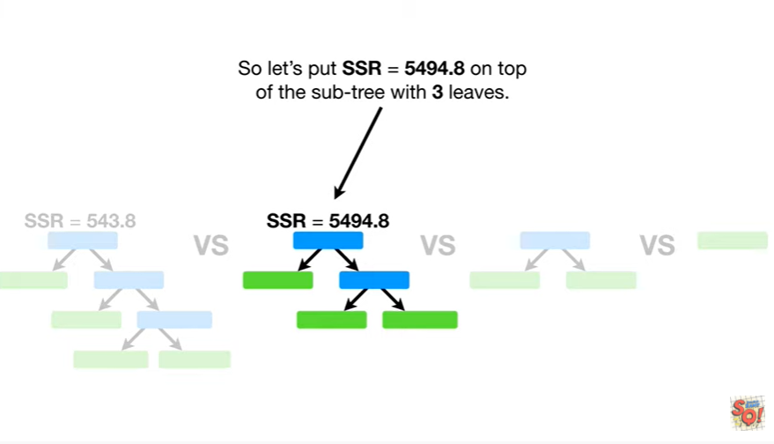

So let's put SSR equals five thousand four hundred ninety four point eight on top of the sub tree with three leaves.

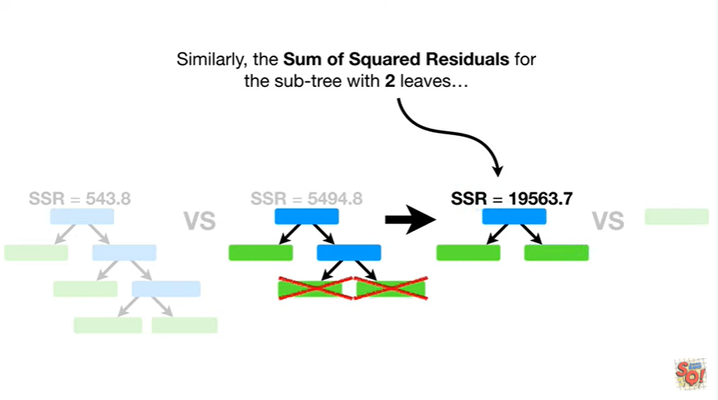

Similarly the sum of squared residuals for the subtree with two leaves

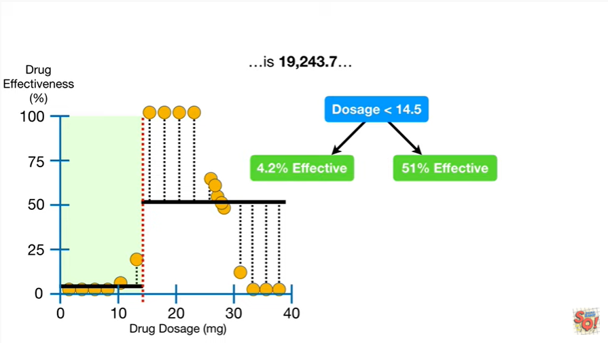

is nineteen thousand two hundred forty three point seven

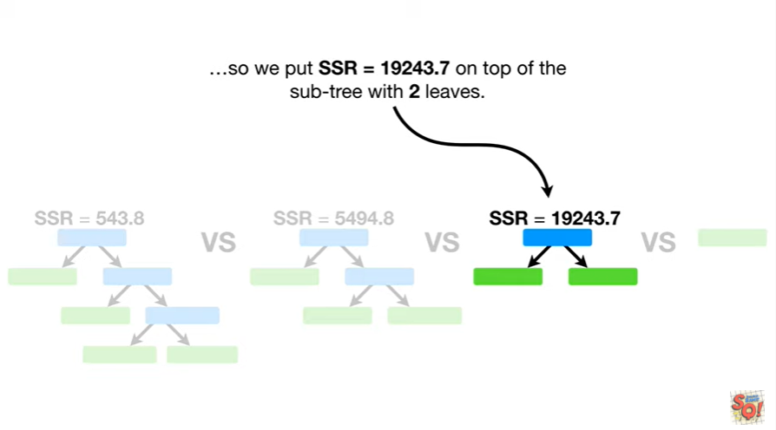

So we put SSR equals nineteen thousand two hundred forty three point seven on top of the subtree with two leaves.

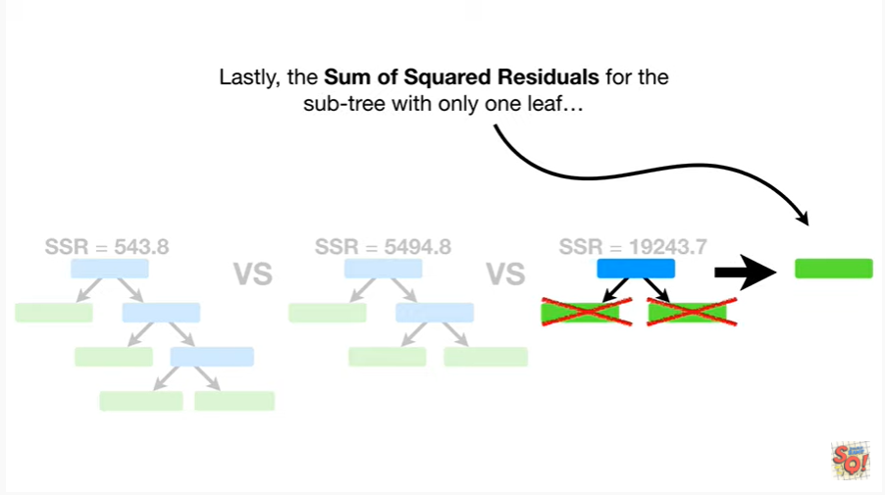

Lastly the sum of squared residuals for the subtree with only one leaf

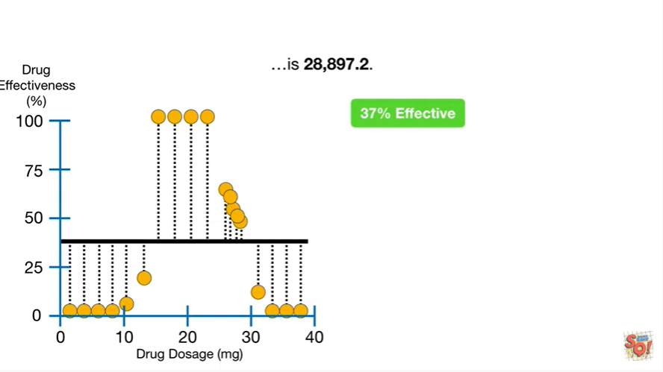

is twenty eight thousand eight hundred ninety seven point two

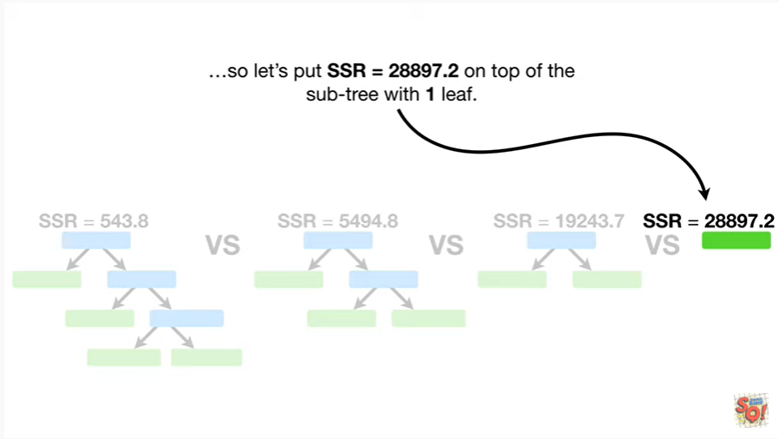

so let's put SSR equals twenty eight thousand eight hundred ninety seven point two on top of the sub tree with one leaf.

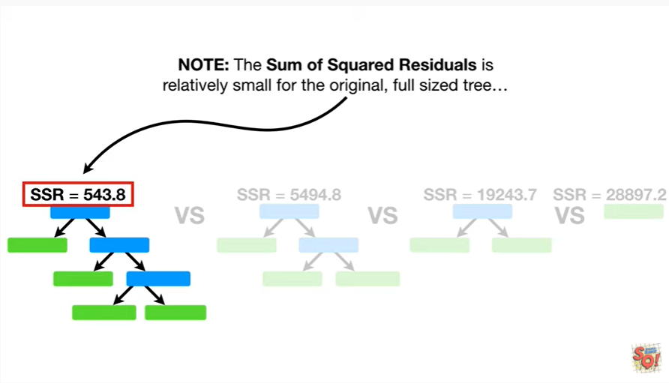

Note : the sum of squared residuals is relatively small for the original full-size tree

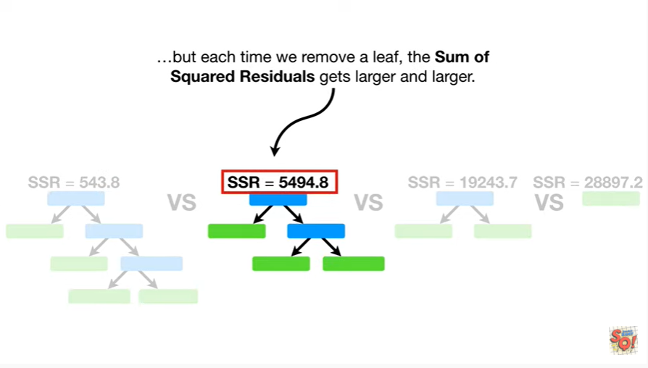

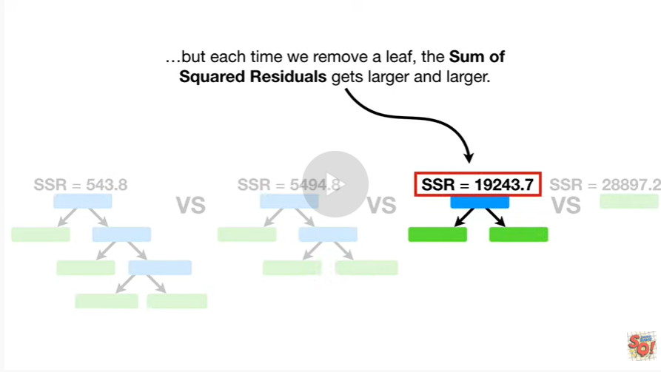

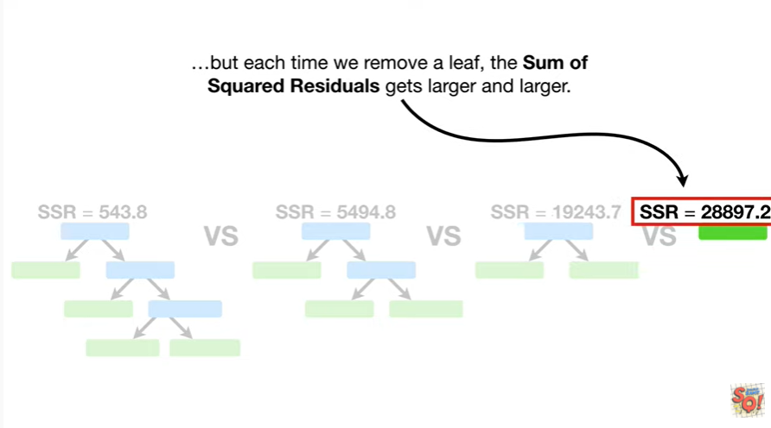

but each time we remove a leaf the sum of squared residuals gets larger and larger.

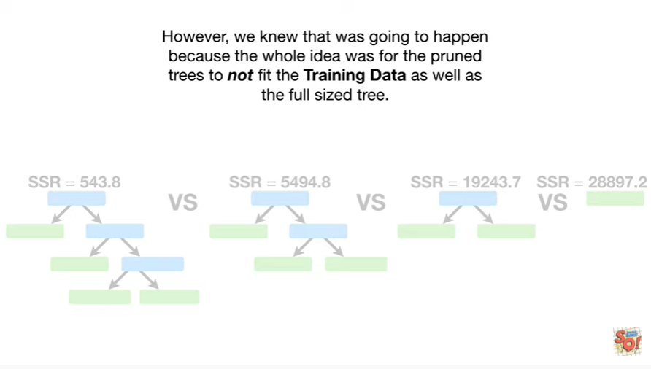

However, we knew that was going to happen because the whole idea was for the pruned trees to not fit the training data as well as the full sized tree.